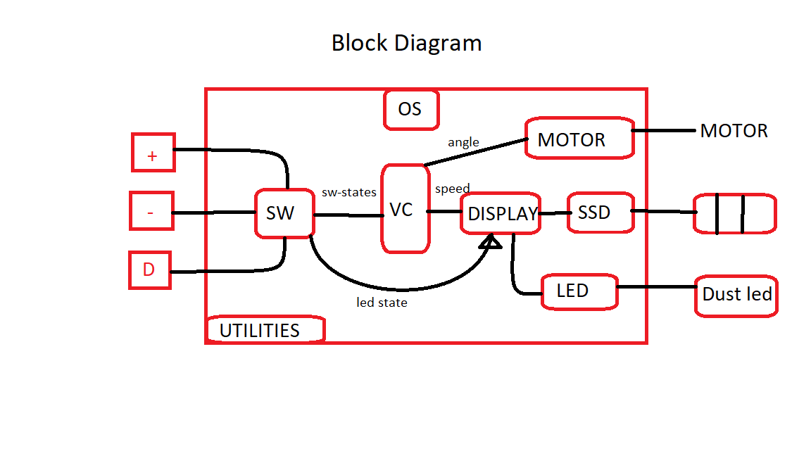

|  |  |  |  |
| --- | --- | --- | --- |
| Period of tasks | Period of actions | Actions | Tasks |
| 20 | 20 | Sample | SW |
| 20 | state |
| 20 | 20 | speed | VC |
| 20 | angle |
| 20 | 20 | SSD | Display |
| 20 | Led |
| 10 | 10 | SSD | SSD |
| 10 | 10 | Fire | Motor |
| 80 | Soft switching |
| 20 | harmonics |

So the Tick will be 10 ms

And major cycle is 20 ms